**Capstone Project Name :Product Dissection for meesho**

**Name : Abhishek Thakur**

**Github Link :** [**https://github.com/AbhishekThakur0126/Product-Dissection-for-meesho-App**](https://github.com/AbhishekThakur0126/Product-Dissection-for-meesho-App)

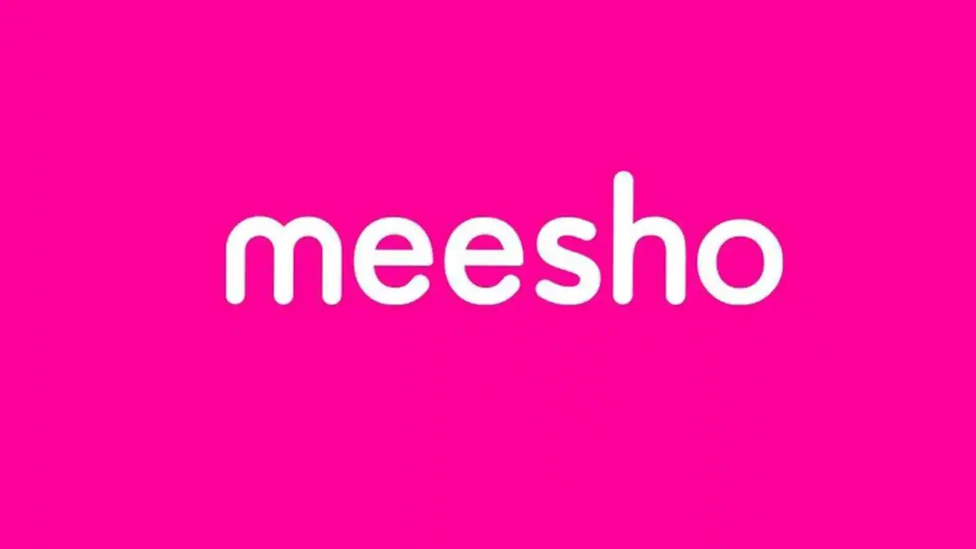

**Project Overview:**

**Problem Statement:**

Welcome to this case study on dissecting and designing products for top leading platforms. In this case study, you will delve into the intriguing world of schema design for a prominent platform of your choice. Your task is to choose a top leading platform, research its features, and meticulously craft a schema design that encapsulates the essence of its functionality. By focusing on key entities, attributes, and relationships, you will gain invaluable insights into how data architecture drives the platform's effectiveness.

### **Company Overview:**

**Company Name:** **meesho**  
**Founders:** Vidit Aatrey and Sanjeev Barnwal  
**Launch Date:** July 2015

**Company Headquarters:** Bengaluru, Karnataka, India

**Meesho** is an Indian social commerce platform that allows users to discover, share, and buy products from a variety of suppliers. It is one of the fastest-growing e-commerce companies in India, with over 100 million users. Meesho is particularly popular in Tier 2 and 3 cities, where it has become a go-to platform for buying affordable products.

Here's how Meesho generally works:

1. **Product Selection**: Meesho partners with suppliers and manufacturers to provide a wide range of products. Resellers can browse through these products and choose the ones they want to sell.

2. **Reselling**: Resellers, often referred to as "social sellers," share the selected products with their network through social media platforms. They can set their own profit margins.

3. **Order Placement**: When a customer places an order, the reseller collects the payment and places the order on the Meesho app. Meesho takes care of the packaging and delivery of the product directly to the customer.

4. **Earnings**: The reseller earns a commission on each sale, which is the profit margin they set minus the cost price of the product.

Meesho has gained popularity as it provides individuals, especially women and housewives, with an opportunity to start their own business without the need for upfront investment. It has played a significant role in promoting entrepreneurship and micro-businesses in India.

### **Product Dissection and Real-World Problems Solved by Meesho:**

## 

## **Product Dissection**

**Meesho** is a social commerce platform that connects buyers with sellers through a network of resellers. It operates on a zero-inventory model, which means that Meesho does not own or stock any of the products that are sold on its platform. Instead, it relies on its network of resellers to fulfill orders.

Meesho's key features include:

* A curated catalog of products: Meesho's catalog of products is carefully curated to ensure that only high-quality products are sold on its platform.
* Personalized recommendations: Meesho uses machine learning to personalize product recommendations for each user.
* A social media-like interface: Meesho's interface is designed to be social and engaging, making it easy for users to discover new products and connect with other users.
* Cash on delivery (COD): Meesho offers cash on delivery as a payment option, which is particularly popular in India where many people do not have credit cards.
* Easy returns and refunds: Meesho has a hassle-free returns and refunds policy, which makes it easy for users to return or exchange products that they are not satisfied with.

## **Real-World Problems Solved by Meesho**

Meesho solves a number of real-world problems for buyers, sellers, and the Indian economy as a whole.

**For buyers:**

* Meesho provides buyers with a wide range of affordable products to choose from.
* Meesho makes it easy for buyers to discover new products and connect with other users.
* Meesho's cash on delivery option makes it easy for buyers to pay for their purchases.
* Meesho's easy returns and refunds policy makes it easy for buyers to return or exchange products that they are not satisfied with.

**For sellers:**

* Meesho provides sellers with a platform to reach a wider audience and sell their products online.
* Meesho's zero-inventory model makes it easy for sellers to start and grow their businesses.
* Meesho's logistics and payments platforms make it easy for sellers to fulfill orders and receive payments.
* Meesho's marketing platform helps sellers promote their products and reach more customers.

**For the Indian economy:**

* Meesho is helping to boost economic growth in India by providing small businesses with the tools and resources they need to succeed.
* Meesho is creating jobs in India by empowering entrepreneurs to start their own businesses.
* Meesho is making it easier for people in Tier 2 and 3 cities to access affordable products and services.

Overall, Meesho is a well-designed and executed product that is solving a number of real-world problems for buyers, sellers, and the Indian economy as a whole. The company is well-positioned for continued growth in the years to come.

### 

### **Case Study: Real-World Problems and Meesho Innovative Solutions:**

**Meesho**, an Indian social commerce platform, has emerged as a disruptor in the e-commerce landscape, addressing several real-world problems and offering innovative solutions to empower both buyers and sellers. Here's a closer look at the challenges tackled by Meesho and its innovative approaches:

**Real-World Problems Addressed by Meesho:**

1. **Limited Access to Affordable Products:** In Tier 2 and 3 cities in India, access to a wide range of affordable products was limited, often confining consumers to local markets or brick-and-mortar stores with restricted options.
2. **Challenges for Small Businesses:** Small businesses and entrepreneurs faced difficulties in reaching a wider audience and effectively marketing their products through traditional channels.
3. **Technological Gap and E-commerce Adoption:** The adoption of e-commerce among consumers in Tier 2 and 3 cities was hindered by a lack of familiarity with technology and limited access to internet services.
4. **Trust Issues and Payment Concerns:** Online transactions often raised trust concerns, especially in regions with lower credit card penetration, making cash on delivery (COD) a crucial requirement.

**Innovative Solutions Offered by Meesho:**

1. **Curated Product Catalog and Personalized Recommendations**: Meesho curates a catalog of high-quality products at affordable prices, catering to the diverse needs of consumers in Tier 2 and 3 cities. Additionally, personalized recommendations based on user preferences and purchase history enhance the shopping experience.
2. **Social Commerce Approach and Reseller Network:** Meesho's social commerce model leverages a network of resellers, primarily women entrepreneurs, who act as local intermediaries, bridging the gap between buyers and sellers. This approach fosters trust and facilitates transactions.
3. **Cash on Delivery (COD) Option**: Meesho recognizes the prevalence of COD as a preferred payment method in India, particularly in Tier 2 and 3 cities. Offering COD as a primary payment option ensures accessibility and convenience for a wider range of consumers.
4. **User-Friendly Interface and Simplified Language:** Meesho's interface is designed to be simple and intuitive, making it easy for users with varying levels of technological literacy to navigate the platform. The use of local languages further enhances user engagement and accessibility.
5. **Logistics and Payments Infrastructure:** Meesho has established a robust logistics and payments infrastructure to ensure seamless order fulfillment and secure transactions. This infrastructure empowers small businesses to manage their online operations effectively.
6. **Marketing Support and Training Programs**: Meesho provides marketing support and training programs to its network of resellers, enabling them to effectively promote their products and reach a wider customer base. This support empowers entrepreneurs and boosts their earning potential.
7. **Community Building and Social Engagement:** Meesho fosters a sense of community by encouraging social interaction and engagement among its users. This approach creates a more personalized and enjoyable shopping experience.
8. **Focus on Tier 2 and 3 Cities:** Meesho's focus on Tier 2 and 3 cities addresses the underserved market segment, providing consumers in these regions with access to a wider range of products and services.
9. **Empowering Women Entrepreneurs:** Meesho's reseller network predominantly comprises women entrepreneurs, providing them with an opportunity to establish their businesses, generate income, and contribute to the local economy.
10. **Promoting Digital Inclusion and Internet Adoption**: By providing a user-friendly and accessible e-commerce platform, Meesho encourages digital inclusion and promotes the adoption of internet services in Tier 2 and 3 cities.

In conclusion, Meesho's innovative solutions have effectively addressed several real-world problems, transforming the e-commerce landscape in India. By catering to the needs of consumers and businesses in Tier 2 and 3 cities, Meesho has democratized access to products, services, and opportunities, paving the way for a more inclusive and digitally empowered India.

### **Top Features of Meesho:**

**Meesho**, a leading social commerce platform in India, has gained immense popularity due to its innovative features and user-friendly approach. Here are some of the key features that make Meesho stand out in the e-commerce landscape:

1. **Curated Product Catalog:** Meesho meticulously curates its product catalog to ensure that only high-quality products from trusted sellers are featured. This ensures a positive shopping experience for buyers.
2. **Personalized Recommendations:** Meesho leverages machine learning algorithms to provide personalized product recommendations based on each user's browsing history, purchase behavior, and preferences. This tailored approach enhances the shopping experience and increases the likelihood of successful purchases.
3. **Social Commerce Model:** Meesho's social commerce model revolves around a network of resellers, primarily women entrepreneurs, who act as local intermediaries, connecting buyers with sellers. This approach fosters trust, encourages social interaction, and facilitates transactions in regions where traditional e-commerce models may not be as prevalent.
4. **Cash on Delivery (COD) Option:** Recognizing the preference for COD in India, Meesho offers it as a primary payment method, providing flexibility and convenience for buyers, especially in regions where credit card penetration is lower.
5. **Easy-to-Use Interface and Simplified Language:** Meesho's interface is designed to be simple, intuitive, and user-friendly, making it accessible to users with varying levels of technological literacy. The use of local languages further enhances accessibility and engagement.
6. **Logistics and Payments Infrastructure**: Meesho has established a robust logistics and payments infrastructure to ensure seamless order fulfillment and secure transactions. This infrastructure empowers sellers, particularly small businesses, to manage their online operations effectively.
7. **Marketing Support and Training Programs:** Meesho provides comprehensive marketing support and training programs to its network of resellers, equipping them with the skills and knowledge to effectively promote their products and reach a wider customer base. This support empowers entrepreneurs and boosts their earning potential.
8. **Community Building and Social Engagement:** Meesho encourages social interaction and engagement among its users, creating a sense of community and fostering a more personalized and enjoyable shopping experience. Features like group chats and product reviews encourage interaction and build trust.
9. **Focus on Tier 2 and 3 Cities:** Meesho prioritizes serving the underserved market segment of Tier 2 and 3 cities, providing consumers in these regions with access to a wider range of products and services, bridging the gap between urban and rural areas.
10. **Empowering Women Entrepreneurs:** Meesho's reseller network predominantly comprises women entrepreneurs, providing them with an opportunity to establish their businesses, generate income, and contribute to the local economy. This empowerment aligns with Meesho's mission to democratize access to e-commerce and promote inclusive growth.

### **Schema Description and Design :**

The schema for meesho involves multiple entities that represent different aspects of the platform. Each entity has specific attributes that describe its properties and relationships with other entities.

**Customer:**

Information about each user

* **customer_Id:** the unique id to identify the user.
* **first_name:** the first name of the consumer.
* **last_name:** the last name of the consumer.
* **Phone_number:** the mobile number of the user. It is used for registration and login purposes.
* **Email:** the email of the user. It is used for login purposes
* **Password:** the password of the consumer.
* **Address:** the address of the consumer.

**Cart:**

* **Cart_id:** the unique id to identify the cart.
* **Quantity:** the quantity of the product selected by the user.

**Wishlist:**

* **Wishlist_id:** the unique id to identify the wishlist.

**Product:**

Data about products available

* **Product_Id:** the unique id to identify the product.
* **SKU:** the stock unit product of the product.
* **description:** the description displays the features of product.
* **Stock:** the stock shows the number of quantities available.
* **Price:** the final price of product

**Category:**

* **category_id :** the unique id to identify the category of a product.
* **Name :** the name of the category of product.

**Order:**

* **Order_id :** the unique id to identify the order.
* **Order_date:** the order date/time of the ordered product.
* **Total_price:** total amount payable for the product.

**Order_Item:**

* **order_item_Id:** the unique id to identify the order item.
* **Quantity:** the quantity of the product selected by the user.
* **Price:** price of the product.

**Payment:**

* **payment_Id:** the unique id to identify the payment id.
* **payment_date:** the payment date displays the date on which the payment made.
* **Payment method:** payment method displays the method through which payment made.
* **amount:** the total price of the product including shipping cost and excluding discount.

**Shipment :**

* **shipment_Id:**  the unique id is to identify the shipment.
* **shipment_date:** the date of shipment.
* **address:** the address to which the shipment was made..
* **City:** the city of shipment address.
* **State:** the state of shipment address.
* **Zip_code:** the zip code of shipment address.

**Relationships are:**

* **Customer select product –** Each user can select multiple products.
* **Customer Cart –** Users can add all the details.
* **Customer wishlist -** Users can add item to the wishlist.
* **Customer payment -** Users can make the payment.
* **Customer product –** Users get details about the product.
* **Customer category-** Users choose the category of the product.
* **Customer place Order–** Users can place an order
* **Customer shipment-** Users add all the shipment details.

**ER Diagram:**

Let's construct an ER diagram that exactly portrays the relationships and attributes of the entities within the flipkart schema.

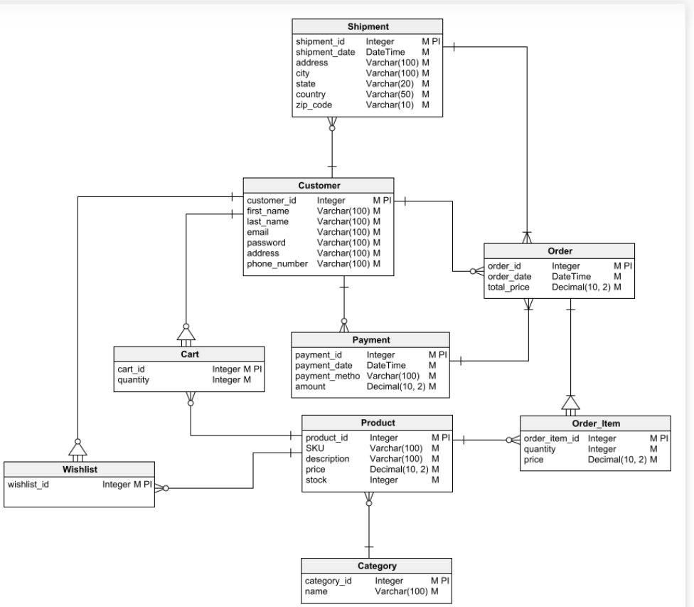

**Conclusion:**

Meesho's innovative approach to social commerce has transformed the e-commerce landscape in India, particularly in Tier 2 and 3 cities. By addressing the needs of both buyers and sellers, Meesho has democratized access to products, services, and opportunities, fostering inclusive growth and empowering women entrepreneurs.

* Addressing real-world problems: Meesho has successfully addressed real-world problems such as limited access to affordable products, challenges for small businesses, and technological gaps.
* Innovative solutions: Meesho's innovative solutions, including its social commerce model, focus on Tier 2 and 3 cities, and empowerment of women entrepreneurs, have set it apart in the e-commerce industry.
* User-centric approach: Meesho's user-centric approach, evident in its curated product catalog, personalized recommendations, and easy-to-use interface, has enhanced user experience and satisfaction.
* Empowering women entrepreneurs: Meesho's reseller network has provided a platform for women entrepreneurs to establish businesses, generate income, and contribute to the local economy.
* Promoting digital inclusion: Meesho's focus on Tier 2 and 3 cities has promoted digital inclusion and encouraged the adoption of internet services in underserved regions.

In conclusion, Meesho stands as a testament to the power of innovation in addressing social and economic challenges. Its success story highlights the potential of technology to democratize access and empower individuals, particularly in developing economies.

**Video Explaination :**

https://drive.google.com/file/d/1Cshjwh4Jvwyc4p26SeSrmqeG0F-HbtzV/view?usp=sharing

**Technical Documentation:**

https://docs.google.com/document/d/1j2v_XjbkgT0HFlz6QhPpZYOOrKqADz7fQfJpmP9baMU/edit?usp=sharing